1. download and indtall xampp for the database from this site

https://www.apachefriends.org/download.html

1. open apache and mysql and go to <http://localhost/phpmyadmin/>

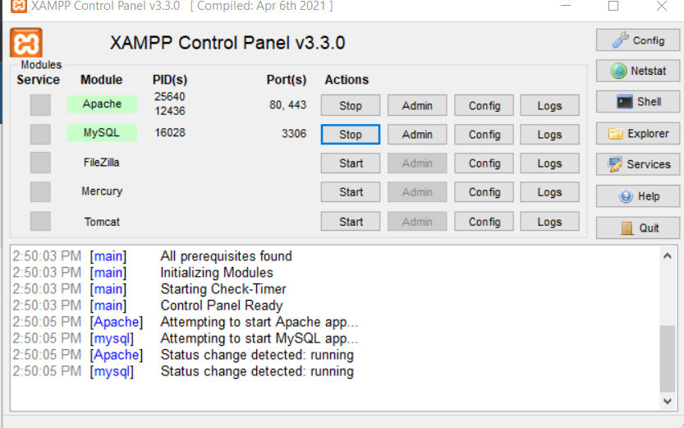

1. create new database name it 'exams' in the phpmyadmin page

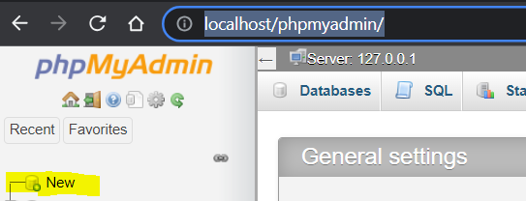

1. click import tab and click choose file import database from the database folder

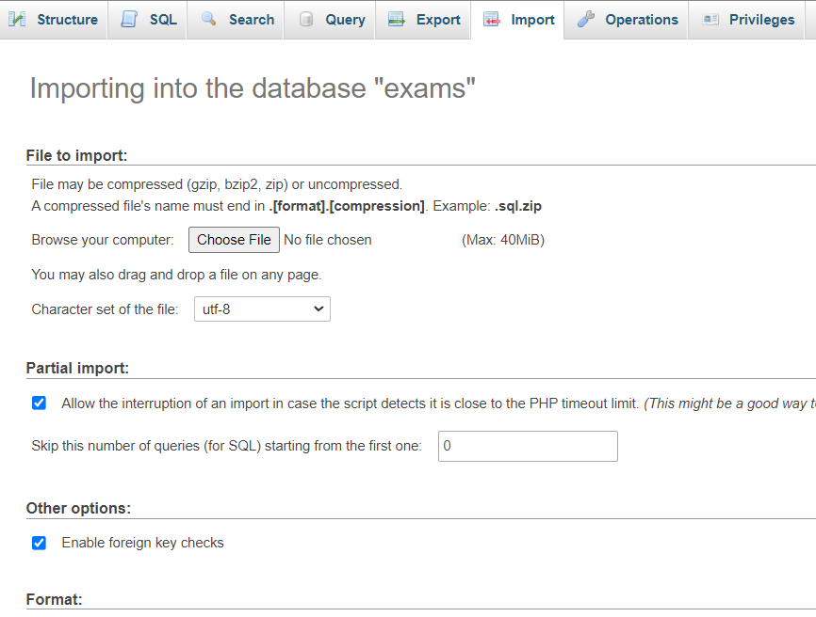

5. clone the project open in the terminal the server and client folder

6. inside the client and server folder type npm install

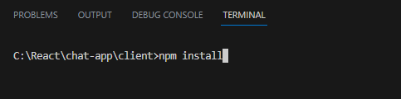

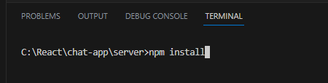

7. and type npm start both client and server on the terminal